**FLAG DAY 2024 in DOUGLAS** 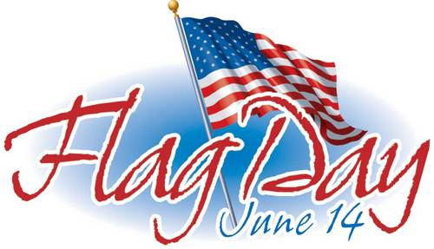

Thank you, all Douglas residents, business & organizations for flying out country’s flag,

Friday, June 14. Over 100 United States of America Flags and Alaska State Flags today! The Douglas 4th of July Committee gives special thanks to those who went further in decorations of red, white and blue on their properties.

The Douglas Fire Fighters did the judging Friday evening.

Walk or drive around to view the owner’s decorations at the following addresses & others.

Please let them know that Douglas appreciates their efforts.

**Best Patriotic Spirit**

**First Place 503 F Street**

**BEST House**

**First Place 531 5th Street**

**Second Place 204 5th Street**

**BEST Duplex**

**First Place 1005 2nd Street**

**BEST Decorated Fence**

**First Place 643 St Anns Ave**

**BEST Decorated Outdoor Space**

**First Place 1204 4th Street**

**Second Place 107 5th Street**

**BEST Condo / Apartment**

**First Place Seaside Condos, 900 1st Street**

**Second Place Cliff House, 600 St Anns Ave**

**BELLA’S CHOICE**

**First Place 811 5th Street**

**JUDGE’S CHOICE**

**First Place 103 Bradley Street**

***VIEW Other Places around Douglas:*** Please continue to put up decorations.

Thank you, Douglas Residents, for showing off your Red, White and Blue. [www.douglas4thofjuly.com](http://www.douglas4thofjuly.com)